**Lesson 11 Demo 1**

**Installing Docker on Windows and Linux**

Steps to be followed:

1. Install Docker on Windows Platform
2. Install Docker on Linux Platform

**Step 1: Install Docker on Windows Platform.**

1. Download windows exe file from below link:

https://hub.docker.com/editions/community/docker-ce-desktop-windows/

1. Once installer is downloaded, double click on that to proceed with installation.

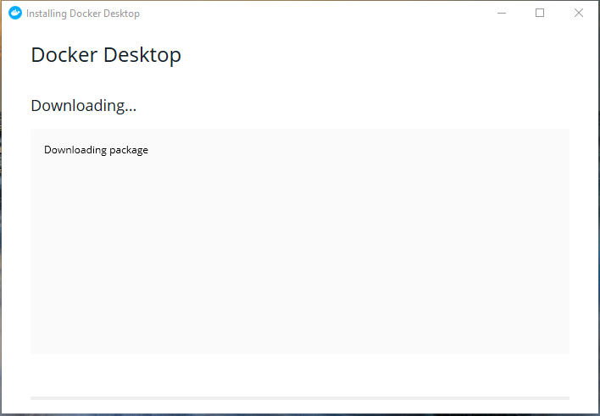

1. Next, we will be getting configuration screen which can be modified according to users’ requirements.

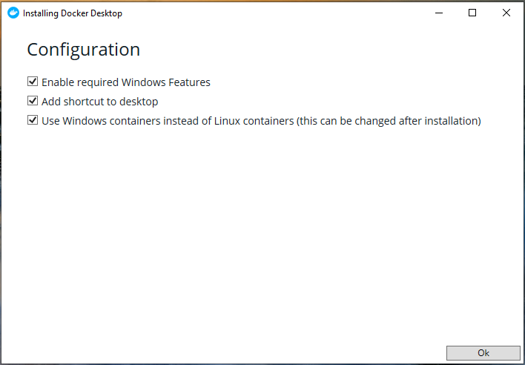

1. Once configurations are done, installation will proceed further.

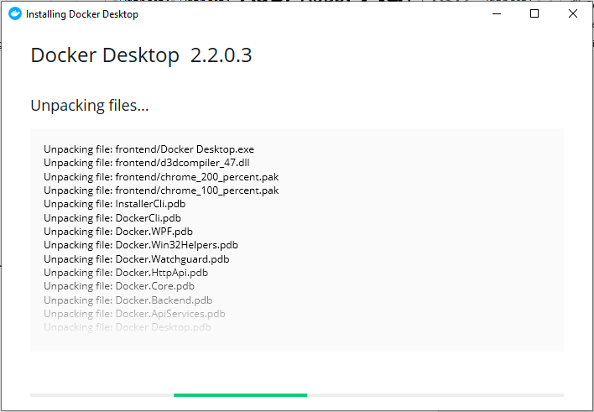

1. Once installation is completed, open command prompt to run Docker version command to check the version of Docker installed.

**Step 2: Install Docker on Linux Ubuntu Platform.**

1. Execute below commands to install Docker on ubuntu Operating system:

**apt update**

**apt install docker.io**

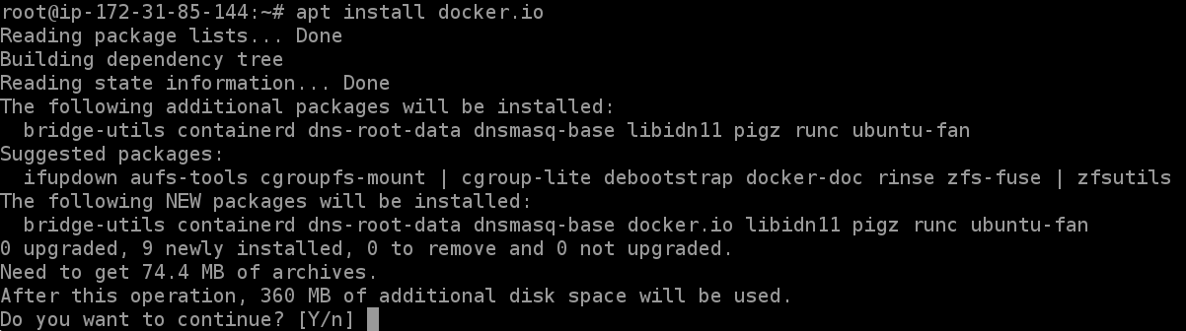

1. Now, to start docker services use:

**sudo systemctl start docker**

1. Now once installation is done, we can run below set of commands which can help us to validate if docker installed properly or not.

docker version

service docker status

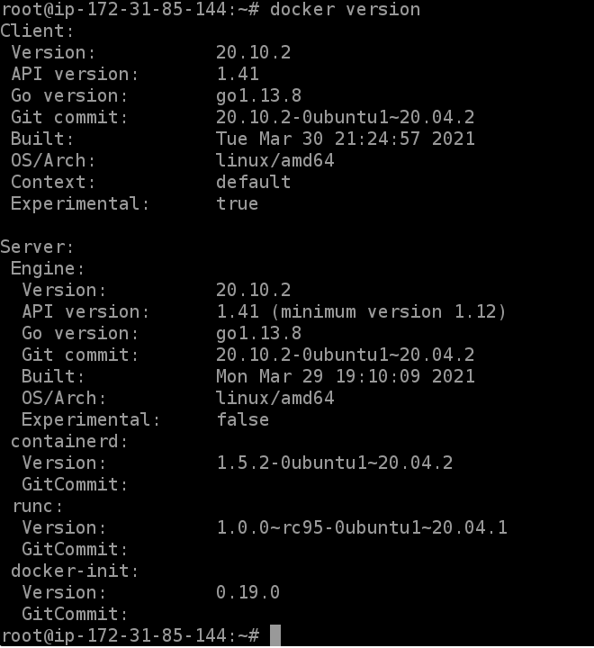

**Step 3: Install Docker on Linux CentOS Platform.**

1. Execute below commands to install Docker on CentOS Operating system:

yum update

yum install -y yum-utils

yum-config-manager --add-repo https://download.docker.com/linux/centos/docker-ce.repo

yum install docker-ce -y

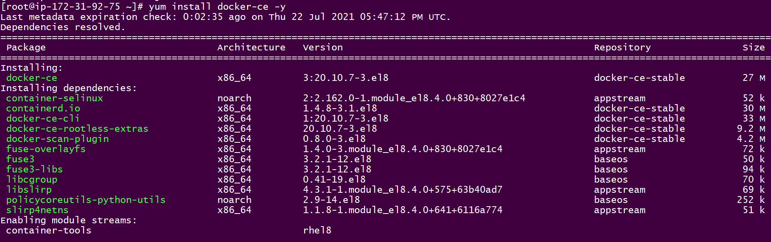

1. Now once installation is done, we can run below set of commands which can help us to validate if docker installed properly or not.

service docker restart

service docker status

docker version

